Assignment No: 1

Q1) Cable types

1. Twisted Pair Cable
Consists of pairs of insulated copper wires twisted around each other to reduce electromagnetic interference (EMI) and crosstalk. This is the standard cable used for local area networks (LANs).
- UTP (Unshielded Twisted Pair): Lacks extra foil shielding; inexpensive, flexible, and standard for everyday home and office networks.
- STP (Shielded Twisted Pair): Wrapped in metallic foil or braided shielding to protect against high electromagnetic interference in industrial environments.
- Standard Connector: RJ45 (8-pin modular plug).
Common Ethernet Categories (UTP/STP):
- Cat5e: Up to 1 Gbps speed, 100 MHz bandwidth.
- Cat6: Up to 10 Gbps (up to 55 meters), 250 MHz bandwidth.
- Cat6a: Up to 10 Gbps (up to 100 meters), 500 MHz bandwidth.
- Cat8: Up to 25/40 Gbps (up to 30 meters), 2000 MHz bandwidth, used in data centers.
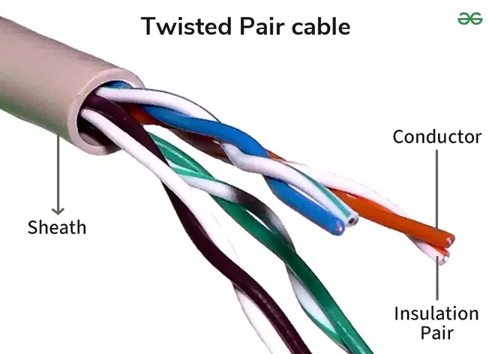

2. Coaxial Cable
Features a central solid copper conductor surrounded by an insulating layer, metallic mesh shielding, and an outer protective jacket. The shielding prevents external signal noise.
- Baseband Coaxial: Transmits a single channel at a time (e.g., 50-ohm cable for traditional Ethernet like 10Base2/10Base5).
- Broadband Coaxial: Transmits multiple signals simultaneously across different frequencies (e.g., 75-ohm cable for cable TV and internet).
- Standard Connectors: BNC, F-type, RCA.
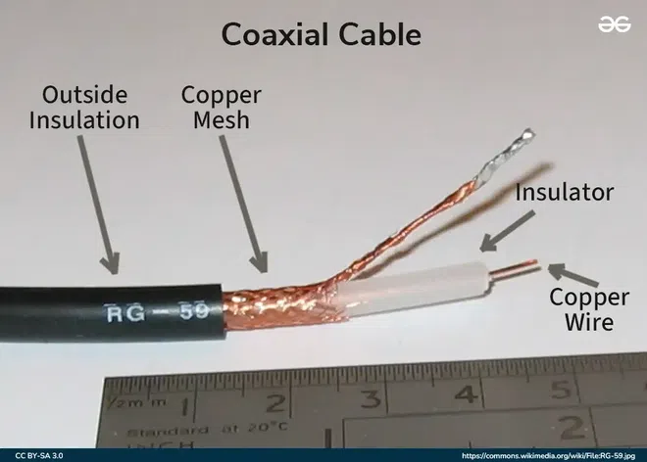

3. Fiber Optic Cable
Transmits data as pulses of light through thin strands of glass or plastic fiber core. It is impervious to electromagnetic interference and supports the highest speeds over the longest distances.
- Single-Mode Fiber (SMF): Very thin core (~9 µm); uses laser light to travel across tens of kilometers with minimal signal degradation. Used for long-haul telecommunications and backbones.
- Multi-Mode Fiber (MMF): Wider core (50–62.5 µm); uses LED light for shorter distances (up to ~500 meters). Common within single-building data centers and local backbones.
- Standard Connectors: LC, SC, ST, MTP/MPO.
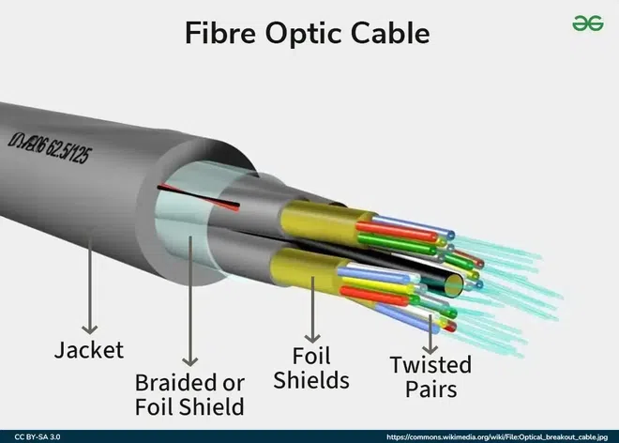

Quick Comparison Matrix
Cable Type | Signal Type | Max Distance | Speed Range | Interference Immunity
Twisted Pair (UTP/STP) | Electrical | 100 meters | 10 Mbps – 40 Gbps | Low to Moderate
Coaxial Cable | Electrical | 200 – 500 meters | 10 Mbps – 1 Gbps | High
Fiber Optic Cable | Light | Up to 40+ km | 1 Gbps – 100+ Gbps | Complete (Immune to EMI)

======================================================================

Q2) Difference between TCP & UDP

TCP (Transmission Control Protocol) and UDP (User Datagram Protocol) are two core protocols of the Transport Layer of the OSI and TCP/IP models. Both are responsible for end-to-end communication between applications, but they differ significantly in terms of reliability, speed, and use cases. Understanding the difference between TCP and UDP is essential for designing efficient and reliable networked systems.
Transmission Control Protocol (TCP)
TCP is a reliable, connection-oriented transport protocol that ensures accurate and ordered data delivery. It uses control mechanisms to guarantee data correctness, which makes it slower but dependable.
- Connection-oriented protocol
- Reliable and ordered data delivery
- Higher overhead but high accuracy
User Datagram Protocol (UDP)
UDP is a fast, connectionless transport protocol that sends data without reliability guarantees. It is efficient for applications where speed is more important than accuracy.
- Connectionless and lightweight
- No guarantee of delivery or order
- Low overhead and high speed

Feature | TCP (Transmission Control Protocol) | UDP (User Datagram Protocol)
Connection Type | Connection-oriented (requires 3-way handshake) | Connectionless (sends data directly)
Reliability | Highly reliable (acknowledgments & retransmissions) | Unreliable (no delivery checks or retries)
Data Transfer Order | Guarantees ordered delivery of packets | No order guaranteed (packets may arrive out of order)
Speed & Efficiency | Slower (higher overhead due to error checking) | Very fast (minimal header overhead)
Header Size | Larger (20–60 bytes) | Lightweight (8 bytes)
Flow & Congestion Control | Supported (prevents receiver/network overload) | Not supported
Data Stream Structure | Stream-based (byte stream) | Datagram-based (discrete packets)
Use Cases | Web browsing (HTTP/HTTPS), Email (SMTP), File transfer (FTP) | Video streaming, Online gaming, VoIP, DNS, Live broadcasts

